Veg h 🡪 Soil T

Temperature decreases and is less variable with higher vegetation – no interaction veg h*pop





Soil T 🡪 Phen

Plants in warmer microsites have an earlier phenology (significative temp*pop only for min T)









BUT: Phenology and vegetation height



Call:

glm(formula = phen_index ~ meanT + veg_h_mean + population, family = "gaussian",

data = data3)

Estimate Std. Error t value Pr(>|t|)

(Intercept) -1.203243 0.582494 -2.066 0.03973 *

meanT 0.130341 0.032077 4.063 6.20e-05 ***

veg_h_mean 0.012866 0.003101 4.149 4.37e-05 ***

populationRemmene 0.244110 0.084439 2.891 0.00412 **

populationTånga Hed 1.044814 0.088497 11.806 < 2e-16 ***

Interaction meant x Veg h not significant

glm(formula = phen_index ~ meanT + population, family = "gaussian",

data = data3)

Estimate Std. Error t value Pr(>|t|)

(Intercept) -0.02730 0.52260 -0.052 0.95838

meanT 0.08675 0.03112 2.787 0.00566 **

populationRemmene 0.14204 0.08295 1.712 0.08788 .

populationTånga Hed 0.90896 0.08443 10.766 < 2e-16 ***

Veg h and Soil T 🡪 Ants

Ant abundance increases with vegetation height and decreases with temperature in all 3 populations





|  |  |
| --- | --- |
|  |  |

Interaction effect?

glm.nb(formula = n_redants ~ veg_h_mean * meanT + population,

data = data3, na.action = "na.fail", init.theta = 0.4779976853,

link = log)

Estimate Std. Error z value Pr(>|z|)

(Intercept) 12.298417 3.690266 3.333 0.00086 ***

veg_h_mean -0.218548 0.106595 -2.050 0.04034 *

meanT -0.694061 0.212771 -3.262 0.00111 **

populationRemmene -0.966343 0.247299 -3.908 9.32e-05 ***

populationTånga Hed 1.568307 0.253605 6.184 6.25e-10 ***

veg_h_mean:meanT 0.014407 0.006255 2.303 0.02126 *

SEMs

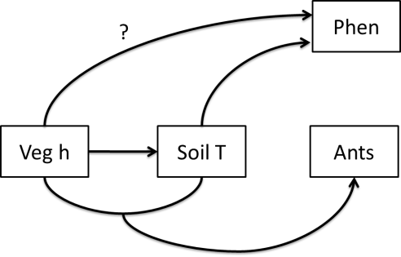

#1 Effects of temperature and vegetation height on phenology

> sem1<-list(

+ glm.nb(n_redants~meanT+veg_h_mean+meanT:veg_h_mean+pop,data=data3),

+ glm(meanT~veg_h_mean+pop,family="gaussian",data=data3),

+ glm(phen_index~meanT+veg_h_mean+pop,family="gaussian",data=data3)

+ )

> sem.fit(sem1,data3,corr.errors=c("meanT:veg_h_mean~~meanT",

+ "meanT:veg_h_mean~~veg_h_mean"))#p=0.297

> sem.coefs(sem1,data3)

response predictor estimate std.error p.value

1 n_redants popT 1.56830732 0.253604788 0.0000 ***

2 n_redants popR -0.96634317 0.247298733 0.0001 ***

3 n_redants meanT -0.69406081 0.212771197 0.0011 **

4 n_redants meanT:veg_h_mean 0.01440749 0.006255013 0.0213 *

5 n_redants veg_h_mean -0.21854803 0.106595191 0.0403 *

6 meanT popR -0.91563058 0.143207350 0.0000 ***

7 meanT veg_h_mean -0.03166011 0.005300288 0.0000 ***

8 meanT popT 0.60639226 0.156171144 0.0001 ***

9 phen_index popT 1.04481351 0.088496595 0.0000 ***

10 phen_index veg_h_mean 0.01286648 0.003101044 0.0000 ***

11 phen_index meanT 0.13034093 0.032077101 0.0001 ***

12 phen_index popR 0.24411021 0.084438713 0.0041 **

#2 Only effect of temperature on phenology

> sem.fit(sem1,data3,corr.errors=c("meanT:veg_h_mean~~meanT",

+"meanT:veg_h_mean~~veg_h_mean","phen_index~~veg_h_mean"))#p=0.191

> sem.coefs(sem1,data3)

#Considered as a correlated error rather than a directed causal path (parallel responses to unmeasured variables – Duffy et al. 2015)

response predictor estimate std.error p.value

1 n_redants popT 1.56830732 0.253604788 0.0000 ***

2 n_redants popR -0.96634317 0.247298733 0.0001 ***

3 n_redants meanT -0.69406081 0.212771197 0.0011 **

4 n_redants meanT:veg_h_mean 0.01440749 0.006255013 0.0213 *

5 n_redants veg_h_mean -0.21854803 0.106595191 0.0403 *

6 meanT popR -0.91563058 0.143207350 0.0000 ***

7 meanT veg_h_mean -0.03166011 0.005300288 0.0000 ***

8 meanT popT 0.60639226 0.156171144 0.0001 ***

9 phen_index popT 0.90896355 0.084431271 0.0000 ***

10 phen_index meanT 0.08675499 0.031124536 0.0057 **

11 phen_index popR 0.14204195 0.082951468 0.0879

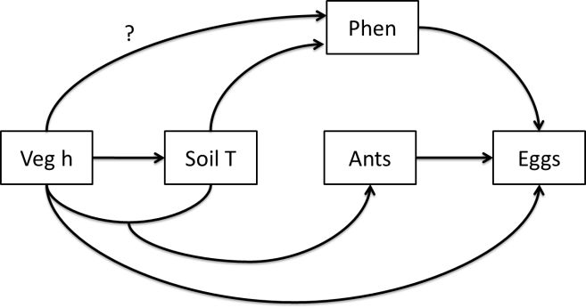

glm.nb(formula = n_eggs_max ~ phen_index + veg_h_mean + n_redants +

pop, data = data3, init.theta = 0.4642244756, link = log)

Estimate Std. Error z value Pr(>|z|)

(Intercept) -0.13235 0.37904 -0.349 0.727

phen_index 0.73160 0.16275 4.495 6.95e-06 ***

veg_h_mean 0.00234 0.00869 0.269 0.788

n_redants 0.01706 0.01041 1.638 0.101

popR 0.21235 0.23045 0.921 0.357

popT -0.05810 0.32448 -0.179 0.858

glm.nb(formula = n_eggs_max ~ phen_index + veg_h_mean + n_redants +

meanT + pop, data = data3, init.theta = 0.5060063245, link = log)

Estimate Std. Error z value Pr(>|z|)

(Intercept) 6.543892 1.657310 3.949 7.86e-05 ***

phen_index 0.857630 0.161693 5.304 1.13e-07 ***

veg_h_mean -0.010782 0.009065 -1.189 0.2343

n_redants 0.018578 0.010119 1.836 0.0664 .

meanT -0.395687 0.093832 -4.217 2.48e-05 ***

popR 0.093138 0.240960 0.387 0.6991

popT 0.204362 0.318250 0.642 0.5208

> sem1<-list(

+ glm.nb(n_eggs_max~phen_index+veg_h_mean+n_redants+pop,data=data3),

+ glm.nb(n_redants~meanT+veg_h_mean+meanT:veg_h_mean+pop,data=data3),

+ glm(meanT~veg_h_mean+pop,family="gaussian",data=data3),

+ glm(phen_index~meanT+pop,family="gaussian",data=data3)

+ )

> sem.fit(sem1,data3,corr.errors=c("meanT:veg_h_mean~~meanT",

+ "phen_index~~veg_h_mean","meanT:veg_h_mean~~veg_h_mean"))#p=0

missing.path estimate std.error df crit.value p.value

1 n_eggs_max ~ meanT*veg_h_mean + ... 0.0010 0.0063 293 0.1528 0.8786

2 n_eggs_max ~ meanT + ... -0.3957 0.0938 294 -4.2170 0.0000 ***

3 n_redants ~ phen_index + ... 0.0140 0.0062 294 2.2516 0.0243 *

$Fisher.C

fisher.c df p.value

1 28.9 6 0

sem.fit(sem1,data3,corr.errors=c("meanT:veg_h_mean~~meanT","phen_index~~veg_h_mean","meanT:veg_h_mean~~veg_h_mean","meanT~~n_eggs_max"))#p=0.024

> sem.coefs(sem1,data3)

response predictor estimate std.error p.value

1 n_eggs_max phen_index 0.731601543 0.162751945 0.0000 ***

2 n_eggs_max n_redants 0.017060102 0.010414109 0.1014

3 n_eggs_max popR 0.212353910 0.230446989 0.3568

4 n_eggs_max veg_h_mean 0.002339562 0.008690180 0.7878

5 n_eggs_max popT -0.058105385 0.324483672 0.8579

6 n_redants popT 1.568307318 0.253604788 0.0000 ***

7 n_redants popR -0.966343166 0.247298733 0.0001 ***

8 n_redants meanT -0.694060806 0.212771197 0.0011 **

9 n_redants meanT:veg_h_mean 0.014407488 0.006255013 0.0213 *

10 n_redants veg_h_mean -0.218548026 0.106595191 0.0403 *

11 meanT popR -0.915630584 0.143207350 0.0000 ***

12 meanT veg_h_mean -0.031660109 0.005300288 0.0000 ***

13 meanT popT 0.606392258 0.156171144 0.0001 ***

14 phen_index popT 0.908963545 0.084431271 0.0000 ***

15 phen_index meanT 0.086754994 0.031124536 0.0057 **

16 phen_index popR 0.142041950 0.082951468 0.0879

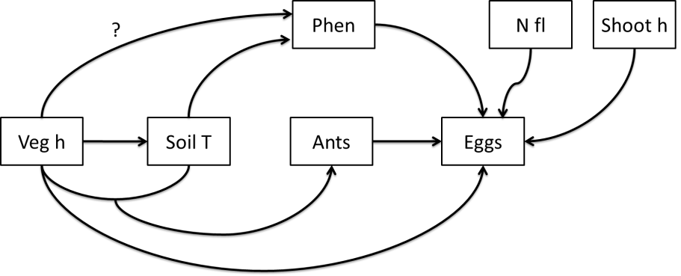

> sem1<-list(

+ glm.nb(n_eggs_max~phen_index+shoot_h+n_fl_corrected+veg_h_mean+n_redants+pop,data=data3),

+ glm.nb(n_redants~meanT+veg_h_mean+meanT:veg_h_mean+pop,data=data3),

+ glm(meanT~veg_h_mean+pop,family="gaussian",data=data3),

+ glm(phen_index~meanT+pop,family="gaussian",data=data3)

+ )

> sem.fit(sem1,data3,corr.errors=c("meanT:veg_h_mean~~meanT","n_eggs_max~~meanT",

+ "phen_index~~shoot_h","phen_index~~n_fl_corrected","shoot_h~~n_fl_corrected",

+ "phen_index~~veg_h_mean","meanT:veg_h_mean~~veg_h_mean"))

$missing.paths

missing.path estimate std.error df crit.value p.value

1 meanT ~ shoot_h + ... -0.0465 0.0095 296 -4.8761 0.0000 ***

2 n_redants ~ shoot_h + ... 0.0146 0.0063 294 2.3403 0.0193 *

3 meanT ~ n_fl_corrected + ... -0.0336 0.0239 296 -1.4038 0.1614

4 n_redants ~ n_fl_corrected + ... 0.0158 0.0063 294 2.5249 0.0116 *

5 n_redants ~ phen_index + ... 0.0140 0.0062 294 2.2516 0.0243 *

$Fisher.C

fisher.c df p.value

1 54.39 10 0

> sem.coefs(sem1,data3)

response predictor estimate std.error p.value

1 n_eggs_max n_fl_corrected 0.18884570 0.040647246 0.0000 ***

2 n_eggs_max popT -0.97275903 0.332498189 0.0034 **

3 n_eggs_max phen_index 0.42880524 0.149784984 0.0042 **

4 n_eggs_max shoot_h 0.04052294 0.016847912 0.0162 *

5 n_eggs_max n_redants 0.02068132 0.009372690 0.0273 *

6 n_eggs_max veg_h_mean -0.01975782 0.008966298 0.0276 *

7 n_eggs_max popR 0.14815214 0.208833960 0.4781

8 n_redants popT 1.56830732 0.253604788 0.0000 ***

9 n_redants popR -0.96634317 0.247298733 0.0001 ***

10 n_redants meanT -0.69406081 0.212771197 0.0011 **

11 n_redants meanT:veg_h_mean 0.01440749 0.006255013 0.0213 *

12 n_redants veg_h_mean -0.21854803 0.106595191 0.0403 *

13 meanT popR -0.91563058 0.143207350 0.0000 ***

14 meanT veg_h_mean -0.03166011 0.005300288 0.0000 ***

15 meanT popT 0.60639226 0.156171144 0.0001 ***

16 phen_index popT 0.90896355 0.084431271 0.0000 ***

17 phen_index meanT 0.08675499 0.031124536 0.0057 **

18 phen_index popR 0.14204195 0.082951468 0.0879

Include missing paths as correlated errors🡪p>0.05

> sem.fit(sem1,data3,corr.errors=c("meanT:veg_h_mean~~meanT","n_eggs_max~~meanT",

+"phen_index~~shoot_h","phen_index~~n_fl_corrected","shoot_h~~n_fl_corrected",

+"phen_index~~veg_h_mean","meanT:veg_h_mean~~veg_h_mean",

+"meanT~~shoot_h","n_redants~~shoot_h","n_redants~~n_fl_corrected","n_redants~~phen_index")) #p=0.161

Tests of correlations

18 ~~ n_eggs_max ~~ meanT -0.21703399 NA 0.9999

19 ~~ phen_index ~~ n_fl_corrected 0.26517390 NA 0.0000 ***

20 ~~ phen_index ~~ shoot_h 0.25416534 NA 0.0000 ***

21 ~~ phen_index ~~ veg_h_mean 0.23443939 NA 0.0000 ***

22 ~~ shoot_h ~~ n_fl_corrected 0.58465538 NA 0.0000 ***

23 ~~ meanT ~~ shoot_h -0.27267898 NA 1.0000

24 ~~ n_redants ~~ shoot_h 0.02451139 NA 0.3359

25 ~~ n_redants ~~ n_fl_corrected -0.06069005 NA 0.8530

26 ~~ n_redants ~~ phen_index -0.13502868 NA 0.9905

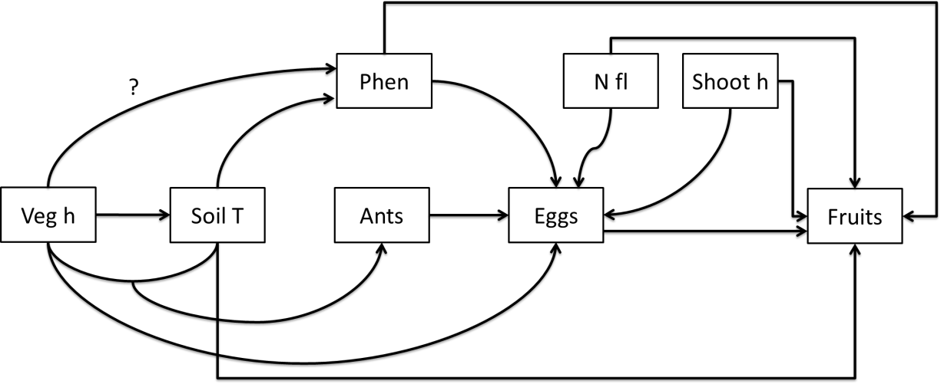

> sem1<-list(

+ glm(n_intact_fruits~phen_index+n_fl_corrected+shoot_h+meanT+n_eggs_max+pop,family="poisson",data=data3),

+ glm.nb(n_eggs_max~phen_index+n_fl_corrected+shoot_h+veg_h_mean+n_redants+pop,data=data3),

+ glm.nb(n_redants~meanT+veg_h_mean+meanT:veg_h_mean+pop,data=data3),

+ glm(meanT~veg_h_mean+pop,family="gaussian",data=data3),

+ glm(phen_index~meanT+pop,family="gaussian",data=data3)

+ )

> sem.fit(sem1,data3,corr.errors=c("meanT:veg_h_mean~~meanT","n_eggs_max~~meanT",

"phen_index~~n_redants","phen_index~~veg_h_mean","meanT:veg_h_mean~~veg_h_mean",

+"phen_index~~n_fl_corrected","shoot_h~~phen_index"shoot_h~~n_fl_corrected"))#p=0

$missing.paths

missing.path estimate std.error df crit.value p.value

1 meanT ~ n_fl_corrected + ... -0.0336 0.0239 296 -1.4038 0.1614

2 n_redants ~ n_fl_corrected + ... 0.0158 0.0063 294 2.5249 0.0116 *

3 meanT ~ shoot_h + ... -0.0465 0.0095 296 -4.8761 0.0000 ***

4 n_redants ~ shoot_h + ... 0.0146 0.0063 294 2.3403 0.0193 *

5 n_intact_fruits ~ veg_h_mean + ... -0.0093 0.0067 292 -1.3874 0.1653

6 n_intact_fruits ~ meanT*veg_h_mean + ... -0.0009 0.0054 291 -0.1686 0.8661

7 n_redants ~ n_intact_fruits + ... 0.0148 0.0062 290 2.3951 0.0166 *

> sem.fit(sem1,data3,corr.errors=c("meanT:veg_h_mean~~meanT","n_eggs_max~~meanT",

"phen_index~~n_redants","phen_index~~veg_h_mean","meanT:veg_h_mean~~veg_h_mean","phen_index~~n_fl_corrected","shoot_h~~phen_index","shoot_h~~n_fl_corrected","meanT~~shoot_h",

"n_redants~~n_fl_corrected","n_redants~~shoot_h","n_redants~~n_intact_fruits"))#p=0.274

> sem.coefs

response predictor estimate std.error p.value

1 n_intact_fruits n_fl_corrected 0.13149329 0.017657121 0.0000 ***

2 n_intact_fruits n_eggs_max -0.05969457 0.008837357 0.0000 ***

3 n_intact_fruits popT 1.30496484 0.218525189 0.0000 ***

4 n_intact_fruits shoot_h 0.02899276 0.010798151 0.0073 **

5 n_intact_fruits phen_index 0.21111870 0.088907448 0.0176 *

6 n_intact_fruits meanT 0.16610428 0.075236132 0.0273 *

7 n_intact_fruits popR -0.56972417 0.311358614 0.0673

8 n_eggs_max n_fl_corrected 0.18884570 0.040647246 0.0000 ***

9 n_eggs_max popT -0.97275903 0.332498189 0.0034 **

10 n_eggs_max phen_index 0.42880524 0.149784984 0.0042 **

11 n_eggs_max shoot_h 0.04052294 0.016847912 0.0162 *

12 n_eggs_max n_redants 0.02068132 0.009372690 0.0273 *

13 n_eggs_max veg_h_mean -0.01975782 0.008966298 0.0276 *

14 n_eggs_max popR 0.14815214 0.208833960 0.4781

15 n_redants popT 1.56830732 0.253604788 0.0000 ***

16 n_redants popR -0.96634317 0.247298733 0.0001 ***

17 n_redants meanT -0.69406081 0.212771197 0.0011 **

18 n_redants meanT:veg_h_mean 0.01440749 0.006255013 0.0213 *

19 n_redants veg_h_mean -0.21854803 0.106595191 0.0403 *

20 meanT popR -0.91563058 0.143207350 0.0000 ***

21 meanT veg_h_mean -0.03166011 0.005300288 0.0000 ***

22 meanT popT 0.60639226 0.156171144 0.0001 ***

23 phen_index popT 0.90896355 0.084431271 0.0000 ***

24 phen_index meanT 0.08675499 0.031124536 0.0057 **

25 phen_index popR 0.14204195 0.082951468 0.0879

26 ~~ n_eggs_max ~~ meanT -0.17617706 NA 0.9989

27 ~~ phen_index ~~ n_fl_corrected 0.26517390 NA 0.0000 ***

28 ~~ phen_index ~~ veg_h_mean 0.23443939 NA 0.0000 ***

29 ~~ phen_index ~~ n_redants -0.11858201 NA 0.9801

30 ~~ shoot_h ~~ n_fl_corrected 0.58465538 NA 0.0000 ***

31 ~~ shoot_h ~~ phen_index 0.26060414 NA 0.0000 ***

32 ~~ meanT ~~ shoot_h -0.27267898 NA 1.0000

33 ~~ n_redants ~~ shoot_h 0.02451139 NA 0.3359

34 ~~ n_redants ~~ n_fl_corrected -0.06069005 NA 0.8530

35 ~~ n_redants ~~ n_intact_fruits -0.08930343 NA 0.9389